**Influence of aquatic habitat quality on *Aedes*, *Anopheles* and *Culex* larval abundance.**

# Introduction

As one of the most important insect vectors of illness, mosquitoes can spread a variety of pathogens that affect both human and animal health. Many mosquito species that transmit illnesses like malaria, yellow fever, Zika, dengue, chikungunya, West Nile virus, and lymphatic filariasis are found in the genera *Aedes*, *Anopheles*, and *Culex*. Due to their extensive geographic spread and their diverse range of breeding environments, they are threatening to public health, especially in tropical, subtropical, and even temperate regions of Africa and Asia.

Mosquitoes propagate by female adults ovipositing in suitable breeding sites. Her choice of egg-laying may be reprimanded by environmental and physiological factors. Gravid females use visual cues and olfactory chemosensors to detect and evaluate potential aquatic larval habitat quality. They are highly receptive to the volatile organic compounds released from stagnant water sources like containers, tyres, puddles, gutters, and natural pools. These chemosignals provide information on the presence of microbial communities and nutrients that will support larval growth. Female mosquitoes also use non-chemical ques when choosing egg deposition sites. They prefer temporary, stagnant water bodies with no predators and high organic content that offer nutrition for filter-feeding larvae.

The qualities of water in breeding sites play a crucial role in both the laying of eggs and the growth of mosquitoes. Habitat quality for a mosquito species may be shaped by many factors including physicochemical properties, competing species and habitat structure. Physicochemical factors such as temperature, turbidity, acidity, and the concentrations of various substances, including ammonia, nitrite, nitrate, sulfate, phosphate, chloride, calcium, and hardness of the water are critical for egg hatching and larval development success (Nikookar et al., 2017). Furthermore, artificial habitats such as tyres, containers, puddles, tyre tracks and gutters may have differential potentiality for mosquito oviposition and larval development. Understanding how different habitat quality govern the abundance and richness of mosquito vector species is crucial for disease prevention and mosquito control efforts.

Nigeria has a high prevalence of malaria, lymphatic filariasis, dengue fever and many other diseases transmitted by mosquito vectors. A better understanding of breeding behavioural patterns among mosquito populations is one of the key elements for reaching the goal of malaria and lymphatic filariasis elimination and eradication. In recent times, control of these vectors by targeting their larva stage -- manipulating their growing condition has been effective. While many studies focus on single populations, there is a paucity of studies showing the multiple effects of physicochemical properties on multiple mosquito populations simultaneously. Physicochemical properties of the habitat may not equally affect every mosquito larva due to species' physiology differences and environmental growth requirements. Not much data currently exists regarding the physiochemical characteristics of mosquito larval habitats for multiple species. Many studies in Nigeria only compare a few physicochemical properties of mosquito abundance, which may be an oversimplification of the multivariable affecting mosquito abundance. Also, very few studies have included species co-occurrence as a factor for population size of this vector larva. However, understanding the variables of topmost importance would be effective for environmental manipulation and target treatment of the vector’s larval stage.

In this study, we conducted a field study to estimate the multivariate effects of physicochemical properties of water and species co-occurrence on *Aedes*, *Anopheles* and *Culex* larva abundance. We also investigated the difference in abundance across habitat types in three ecological zones.We aimed to identify the most important physicochemical properties that affect the larval occurrence.

# Materials and methods

## Data analysis

Statistical analyses were conducted using R version 4.1.3. Artificial habitat types were categorized into five categories: container, gutter, puddles, tyres, and tyre tracks. Only sites that were positive for at least one mosquito sample were included in the analysis. A generalized linear mixed-effects model (GLMM) was developed using a stepwise regression approach with forward selection, employing a Poisson distribution and a log link function. Prior to model construction, predictor variables underwent z-score transformation, resulting in a significant enhancement of the model's performance. Predictor variables demonstrating statistical significance (p < 0.05) were included as fixed effects, while ecozones and habitat types were incorporated as random effects due to their impact on observations. Model selection was guided by second-order Akaike’s information criterion scores (AICc) and Bayesian Information Criterion (BIC), with a series of trial models compared using the anova function. GLMMs were implemented using the lme4 package and the glmer function.

Separate negative binomial models were fitted to assess the impact of habitat type on *Aedes*, *Anopheles*, and *Culex* mosquito abundance. Negative binomial models were chosen over Poisson models due to observed over-dispersion in the data. The model was built with a log (X + 1) transformation was applied to the mosquito abundance variables prior to constructing the negative binomial model. To assess differences among each habitat, Tukey tests for multiple comparisons were conducted using the "glht()" function from the "multcomp" package (Hothorn et al., 2008), given the existence of five distinct habitat levels.

Canonical analysis plots were employed to ordinate mosquito species associated with artificial habitat types. Before this analysis, a significant difference (p < 0.05) in the distribution of mosquito species across habitats was confirmed using the chisq.test function. Following this, a correspondence analysis biplot was generated using CA for analysis and fviz_ca_biplot for visualization.

Principal component analysis (PCA) of physicochemical parameters was conducted using the FactoMineR package. Graphical representations were created using ggplot from the ggplot2 package, while PCA biplots were generated using fviz_ca_biplot from the FactoExtra package.

# RESULT

Overall, 32 habitats were positive for at least one of Aedes, Anopheles and Culex larvae. In total, 642 larva mosquitoes were collected across all sites and habitats. This included 91 *Anopheles*, 200 *Culex* and 351 *Aedes* species. Overall, most mosquitoes were collected from used tyres (320), puddles (210) and containers (43) (see Tabe 1).

Table 1: Mosquito larvae collected at the sampling locations and their abundance.

|  |  |  |  |  |  |
| --- | --- | --- | --- | --- | --- |
| Habitat (n) | Anopheles (%) | Culex (%) | Aedes (%) | Mean ± SD | Total (%) |
| Containers (6) | 0 (0) | 4 | 39 | 7.17±11.29 | 43 (100) |
| Gutters (3) | 21 | 12 | 2 | 11.67±17.62 | 35 (100) |
| Puddles (5) | 25 | 25 | 160 | 42.00±70.03 | 210 (100) |
| Tyre track (5) | 34 | 0 | 0 | 6.80±6.49 | 34 (100) |
| Used tyres (13) | 11 | 159 | 150 | 24.61±20.78 | 320 (100) |

*n= number of samples; SD= Standard Deviation*

Culex larvae were more prevalent in used tyres compared to other environments, with a density of 12.23 ± 15.38. Aedes larvae showed significantly higher densities in both used tyres and puddles compared to other habitats, having mean densities of 11.54±15.34 and 32.00±68.79, respectively.

Used tyres harbored the highest density of Culex larvae (12.23±15.38), significantly differing from other habitats (P<0.05), while Culex larval abundance was highest in used tyres and absent in Tyre tracks.

For Anopheles, larval mosquito abundance did not significantly (P>0.05) differ between gutters (7.00±10.39), puddles (5.00±9.51), and tyre tracks (6.80±6.49). However. Containers had no presence of Anopheles larvae and did not significantly differ from used tyres which had a density of 0.84±2.15.

Culex and Aedes larvae were not observed in tyre tracks, while Aedes larvae were absent in containers.

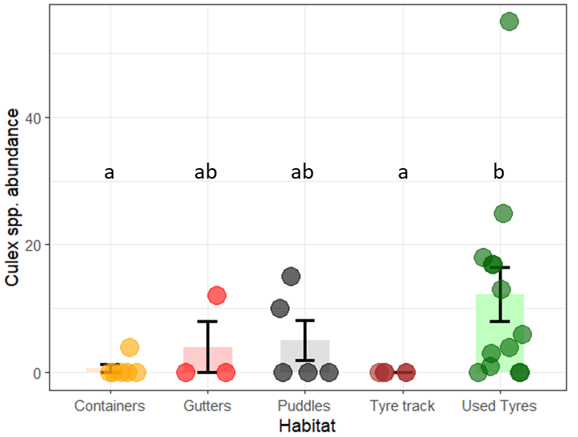

Figure 1: Abundance of *Culex* spp. larva at the artificial habitat.

There was no Culex larva in tyre tracks. However, used tyres, puddles and gutters had mean count of 12.23+15.38, 5.0+7.07 and 4.0+6.93 respectively, which were not statistically different from each other. Furthermore, an average of 0.67+1.63 culex larva was found in containers, but was not statistically different from the culex status in used tyres (0).

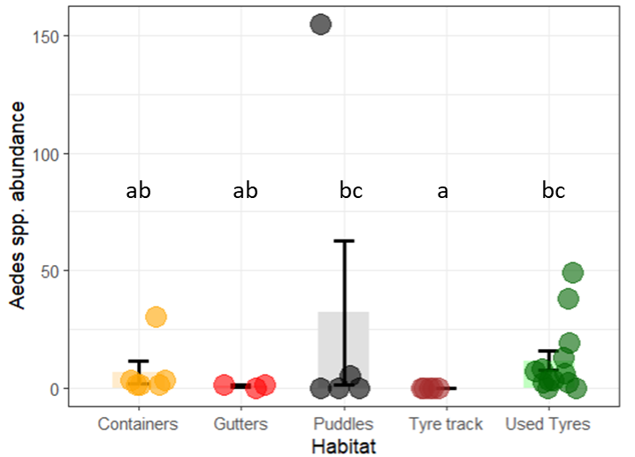

Figure 2: Abundance of Aedes spp. sampled at the artificial habitat

Similar to the occurrence among the sampled culex spp larvae, tyre tracks had no occurrence of Aedes spp. larvae from all samples. Here, puddles had the highest count (32+67.79) of Aedes larvae, though not statistically differing from that in used tyres (11.54+15.33). Furthermore, containers and puddles habitats did not differ significantly from tyre tracks (which had no *Aedes* larvae)

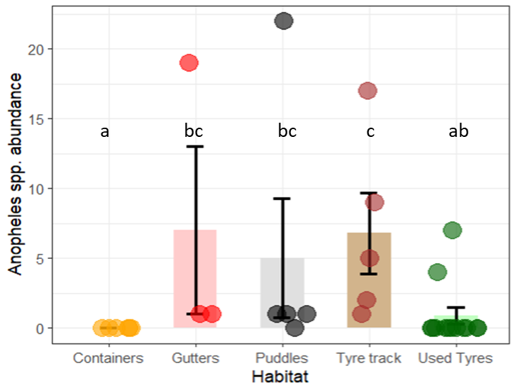

Figure 3: Abundance of Anopheles spp. larva sampled at the artificial habitats.

Unlike Aedes and Culex samples, Contaners had no occurrence of Anopheles, and this was not significantly different from used tyres

Correspondence analysis (CA) biplot showed that *Aedes* was most associated with containers and puddles, Culex with used tyres, and anopheles with Tyre tracks (Figure 5). This supported evidence shown in the descriptive statistics. For example, Aedes had high prevalence in puddles (mean +SE), and Anopheles was mostly found in tyre tracks (mean + SE).

Descriptive statistics of the physicochemical properties are summarized in Table 2. There were variations between habitats and this were simplified using the PCA plot (Figure According to the Principal component analysis (PCA), the first two axes explained 55.5% of total variation. The first axis accounted for 41.2% of data variance, with total solid, suspended solid, colour, magnesium, sulphate, hardness, chloride, turbidity and Nitrate as the variables that most contributed to explaining the dataset variation. All physicochemical parameters were positively correlated with the first dimension, except for DO. TDS, Conductivity, Alkalinity, pH, phosphate and turbidity were the main variables explaining the second component which account for 14.3% of the variance (Figure 7).

PCA of the habitats and ecozones is represented in Figure 4. Puddles and tyre tracks had the most heterogeneous clusters. Containers and used tyres were the most homogenous, with great overlap in their clustering. Furthermore, the PCA ordination showed disparity in the homogeneity physicochemical characteristics of each ecozones. From the ordination plot, the lowland rainforest appeared more homogenous, relative to the large heterogeneity in derived savanna and freshwater swamps.

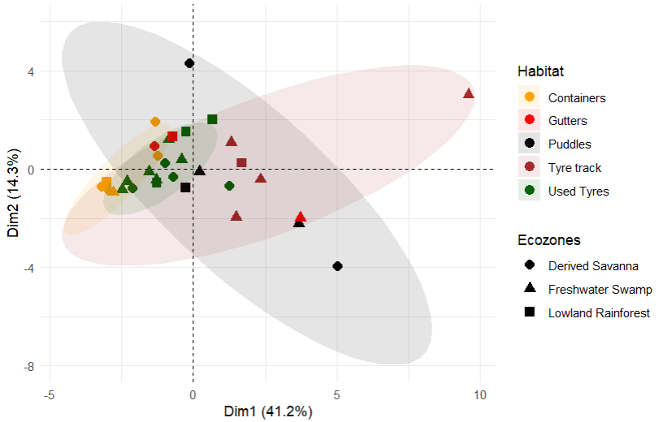

Figure 4: PCA of habitat and their ecozones. Ellipse was set to a 95% confidence interval (CI). However, CI could not be calculated for “Gutters” due to too few data points.

Table 2: Physicochemical properties of mosquito larva habitats, represented as mean ± standard deviation

|  |  |  |  |  |  |
| --- | --- | --- | --- | --- | --- |
| Habitat | Container | Gutters | Puddles | Tyre tracks | Used tyres |
| pH | 6.15±0.35 | 7.03±1.21 | 6.94±0.67 | 7.3±1.01 | 6.6±0.88 |
| Colour | 81.16±36.82 | 1878±2877.07 | 3139.6±2781.72 | 4153.4±31 | 608.15±797.83 |
| Turbidity | 12.333±7.94 | 436.33±661.42 | 817.4±842.95 | 855.8±484.35 | 77.92±89.82 |
| TDS | 57.42±67.32 | 81.27±46.31 | 108.12±104.37 | 106±64.04 | 70.94±30.94 |
| Suspended Solid | 8.33±5.98 | 250.67±378.77 | 374±324.79 | 776±687.10 | 129.92±278.72 |
| Total Solid | 65.75±67.47 | 331.93±370.20 | 482.12±287.72 | 882±730.19 | 200.86±273.88 |
| Conductivity | 108.33±127.03 | 153.33±87.37 | 204±196.93 | 200±120.83 | 133.85±58.39 |
| Chloride | 14.12±6.31 | 32.94±4.07 | 50.832±40.06 | 39.536±22.66 | 22.81±16.34 |
| Alkalinity | 29.33±21.75 | 86±72.58 | 57.6±15.71 | 87.2±66.19 | 53.85±35.11 |
| Hardness as CaCO3 | 25.67±29.59 | 53.33±41.05 | 83.6±66.31 | 116.4±68.31 | 54.15±36.28 |
| Phosphate | 0.49±0.40 | 3.67±2.49 | 36.082±74.12 | 5.046±3.51 | 1.13±0.99 |
| Sulphate | 17.5±18.98 | 88.67±101.93 | 35±26.63 | 119.8±128.26 | 29.46±14.40 |
| Nitrate | 5.94±7.43 | 28.73±37.18 | 28.538±25.68 | 27.14±17.71 | 10.75±11.95 |
| DO | 7.38±1.58 | 4.8±4.42 | 2.62±1.64 | 3.82±2.49 | 4.08±1.82 |
| BOD | 2.56±1.42 | 16.03±20.67 | 10.282±6.69 | 12.54±17.42 | 9.09±14.66 |
| Calcium | 7.61±11.61 | 18.95±15.45 | 26.934±21.08 | 28.70±19.31 | 16.28±13.40 |
| Magnesium | 1.38±1.08 | 1.62±1.13 | 3.988±3.64 | 10.79±9.70 | 2.62±1.65 |

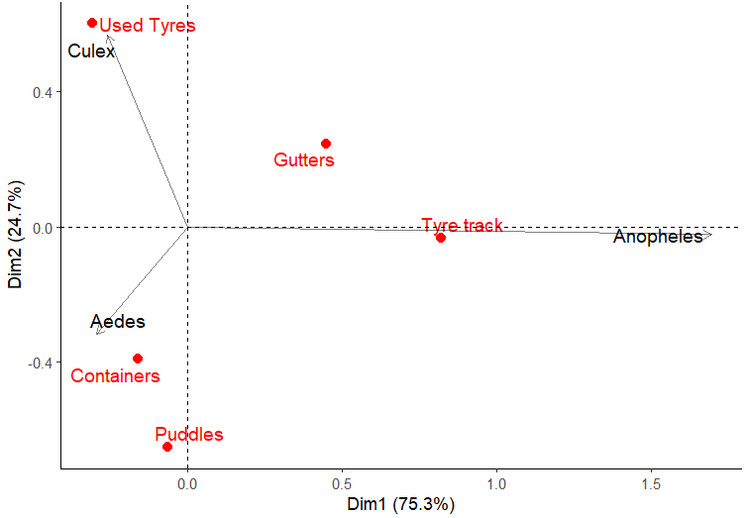

Figure 5: CA biplot representing the relationship between mosquito larvae and the Habitats.

.

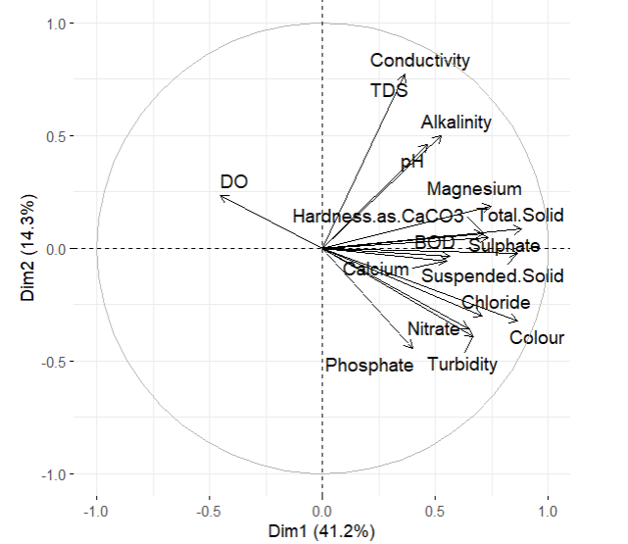

Figure 6: Principal component analysis biplot showing physicochemical parameters of sampling sites in a two-dimension space.

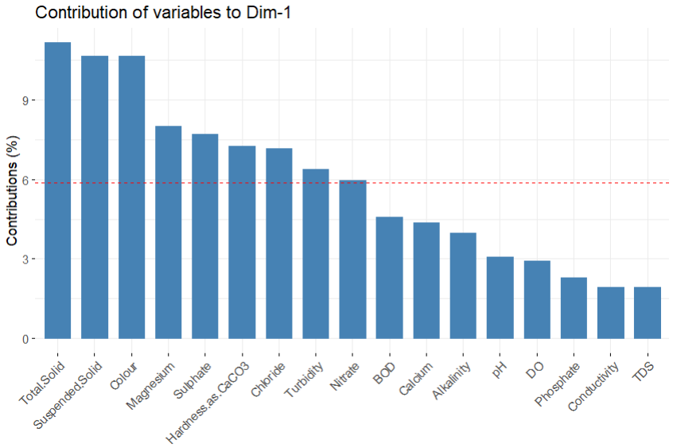

Figure 7: Contribution of physicochemical characteristics surveyed to the first principal component dimension.

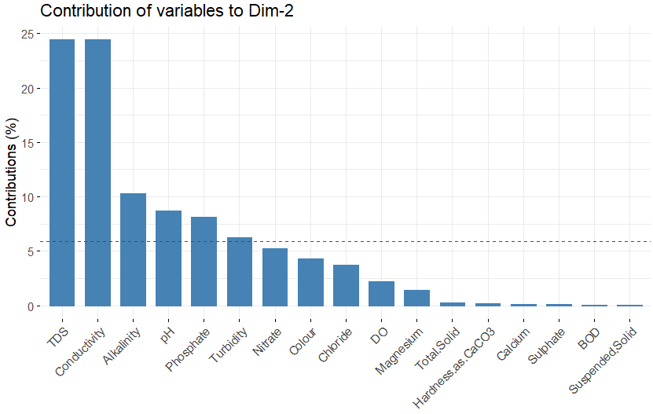

Figure 8: Contribution of physicochemical characteristics surveyed to the second principal component dimension.

Table 3: Results of the generalized linear mixed model (GLMM) of the number of immature Anopheles in larval habitats.

|  |  |  |  |  |  |  |
| --- | --- | --- | --- | --- | --- | --- |
| **Dependent variable** | **Effect** | **Term** | **Estimate** | **SE** | **Z-Value** | **p-value** |
| Anopheles Count | Fixed | Intercept | -0.1065 | 0.9494 | -0.112 | >0.05 |
|  |  | Turbidity | -0.8887 | 0.2863 | -3.104 | <0.01 |
|  |  | DO | -2.6321 | 0.4059 | -6.485 | <0.001 |
|  |  | *Culex* count | -0.5686 | 0.2636 | -2.157 | <0.05 |
|  |  | *Aedes* count | -1.0627 | 0.2632 | -4.037 | <0.001 |
|  |  | Depth | 1.3394 | 0.3687 | 3.633 | <0.001 |
|  |  | Magnesium | -0.6989 | 0.1834 | -3.810 | <0.001 |
|  | Interaction | Turbidity * DO | 1.2109 | 0.2756 | 4.394 | <0.001 |

Turbidity, DO, Depth, Magnesium, Culex and Aedes count influenced the Anopheles abundance. There was an interactive effect between turbidity and DO which had a positive relationship with Anopheles density. Increased depth was positively associated with increased Anopheles abundance, while DO, magnesium, turbidity, Aedes and Culex count were negatively related to their abundance.

Table 4: Results of the generalized linear mixed model (GLMM) of the number of immature Aedes in larval habitats.

|  |  |  |  |  |  |  |
| --- | --- | --- | --- | --- | --- | --- |
| **Dependent variable** | **Effect** | **Term** | **Estimate** | **SE** | **Z-Value** | **p-value** |
| Aedes Count | Fixed |  | -0.7078 | 1.6976 | -0.417 | P >0.05 |
|  |  | Anopheles Count | -0.9053 | 0.2375 | -3.812 | P<0.001 |
|  |  | Suspended Solid | 2.1395 | 0.6143 | 3.483 | P<0.001 |
|  |  | TDS | -1.9979 | 0.1691 | -11.813 | P<0.001 |
|  |  | Chloride | 0.2304 | 0.1486 | 1.550 | P >0.05 |
|  |  | Colour | -3.7158 | 0.3981 | -9.334 | P<0.001 |
|  |  | BOD | -1.9126 | 0.4001 | -4.781 | P<0.001 |

The GLMM model was utilized to predict the prevalence of Aedes larvae. It was constructed with six independent factors (Anopheles population, suspended solids, total dissolved solids (TDS), chloride levels, color, and biological oxygen demand (BOD)), all of which except Chloride showed notable impact on Aedes abundance.

Table 5: Results of the generalized linear mixed model (GLMM) of the number of immature Culicidae in larval habitats.

|  |  |  |  |  |  |  |
| --- | --- | --- | --- | --- | --- | --- |
| **Dependent variable** | **Effect** | **Term** | **Estimate** | **SE** | **Z-Value** | **p-value** |
| Culex Count | Fixed | Intercept | -0.6317 | 1.1381 | -0.555 | P>0.05 |
|  |  | Turbidity | -4.7911 | 0.6119 | -7.830 | P<0.001 |
|  |  | pH | -0.4662 | 0.1768 | -2.636 | P<0.01 |
|  |  | Nitrate | 1.6897 | 0.2405 | 7.025 | P<0.001 |
|  |  | BOD | 0.3048 | 0.1457 | 2.092 | P<0.01 |
|  |  | DO | -0.7392 | 0.2333 | -3.169 | P<0.01 |
|  |  | TDS | -0.8355 | 0.2097 | -3.985 | P<0.001 |
|  | Interaction | DO*TDS | 1.2212 | 0.4028 | 3.032 | P<0.01 |

Culex density was most affected by turbidity, pH, Nitrate, BOD, DO and TDS. GLMM showed that turbidity, pH, DO, and TDS had negative relationships with culex density.

# REFERENCES

David, M. R., Dantas, E. S., Maciel-de-Freitas, R., Codeço, C. T., Prast, A. E., & Lourenço-de-Oliveira, R. (2021). Influence of Larval Habitat Environmental Characteristics on Culicidae Immature Abundance and Body Size of Adult Aedes aegypti. *Frontiers in Ecology and Evolution*, *9*, 626757. https://doi.org/10.3389/fevo.2021.626757

Nikookar, S. H., Fazeli-Dinan, M., Azari-Hamidian, S., Mousavinasab, S. N., Aarabi, M., Ziapour, S. P., Esfandyari, Y., & Enayati, A. (2017). Correlation between mosquito larval density and their habitat physicochemical characteristics in Mazandaran Province, northern Iran. *PLOS Neglected Tropical Diseases*, *11*(8), e0005835. https://doi.org/10.1371/journal.pntd.0005835

Hothorn, T., F. Bretz, and P. Westfall. 2008. “Simultaneous inference in general parametric models.” Biometrical Journal 50: 346–63.